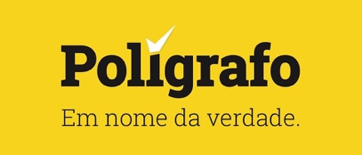

During 2022 we only published one correction/update to a single article. Given that we write around 120 fact checks per month, we think that this is a good barometer for assessing the quality of our editorial methods. The article that was corrected/updated [is available on the website.](https://poligrafo.sapo.pt/institucional/artigos/o-nosso-metodo)

Each day we discuss internally how we can improve our processes to achieve more editorial accuracy and quality. At the end of 2022, the whole team met for two days only to take stock of the year in terms of the quality of the work done.

We concluded that we can improve further in the quality and quantity of sources consulted, which sometimes are not as exhaustive as perhaps they should be. We also believe that we can and should make a renewed efforts to embed more links within our texts, which would easily allow the reader to verify our work.